INDIVIDUAL ASSIGMENT

TECHNOLOGY PARK MALAYSIA

CT047-3-2

SYSTEMS PROGRAMMING AND COMPUTER CONTROL

APD2F2202CS(IS)

HAND OUT DATE : 17 April 2022

HAND IN DATE : 5 June 2022

WEIGHTAGE : 40%

NAME : Ms. Nor Azlina Binti Abd Rahman

NAME : Faithlin Hoe Wei Xin

TP NUMBER : TP055347

**Table of Contents**

1.0 Introduction 3

2.0 System Flow Diagram 4

2.1 Client 4

2.1.1 Sending Data/Signal to Server 4

2.2 Server 5

2.2.1 Receiving Data/Signal from Client 5

2.2.2 Saving Data/Signal into Log 6

3.0 System Features 7

3.1 Sending and Receiving Signals/Data 7

3.2 Logging Activity 9

4.0 Implementation 10

4.1 Client 10

4.1.1 Interface of Client Side 10

4.1.2 Flow of Data 11

4.1.3 The 7 Cases 12

4.2 Server 15

4.2.1 Interface of Server Side 15

4.2.2 Flow of Data 16

4.2.3 The 7 Cases 17

4.2.4 The Setting of Colour for Indicators 20

4.2.5 The Logging of Data/Signal 21

4.3 Block Diagram 22

5.0 Conclusion 23

# 1.0 Introduction

The system that will be explained and documented is a security system that is contracted by a local manufacturer. The purpose of the system is to monitor the perimeter of the manufacturing complex to prevent unauthorized personnel from entering the grounds. The system will be designed using LabVIEW to satisfy the provided specifications.

In this system, there will be six zones with three modes each, which is alarm, bypass and tamper. Each are assigned with the colour red, blue and orange respectively. The indicators would always be green when its normal. The system would display different colour of lights during different situations, and every time a status of a zone is changed, it would be recorded down into a log for reviewing purposes.

# 2.0 System Flow Diagram

## 2.1 Client

## 2.1.1 Sending Data/Signal to Server

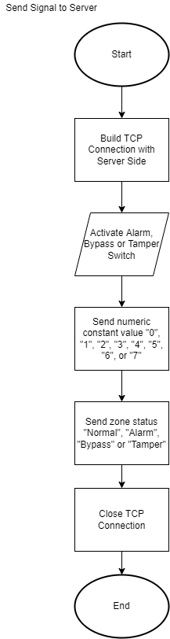

Diagram 1: Flow Diagram of Client Sending Signal/Data to Server

## 2.2 Server

## 2.2.1 Receiving Data/Signal from Client

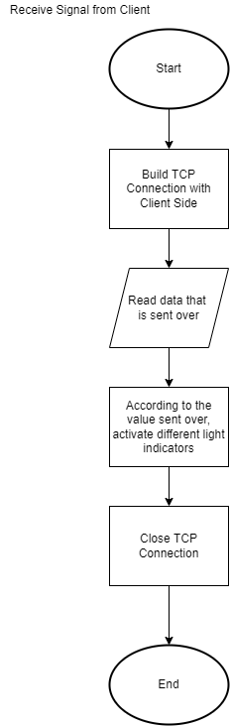

Diagram 3: Flow Diagram of Server Receiving Data/Signal from Client

## 2.2.2 Saving Data/Signal into Log

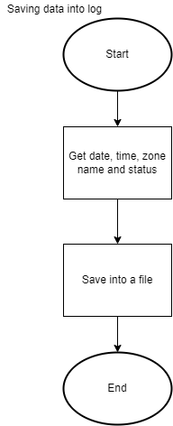

Diagram 2: Flow Diagram of Server Saving Log of Signal Changes

# 3.0 System Features

## 3.1 Sending and Receiving Signals/Data

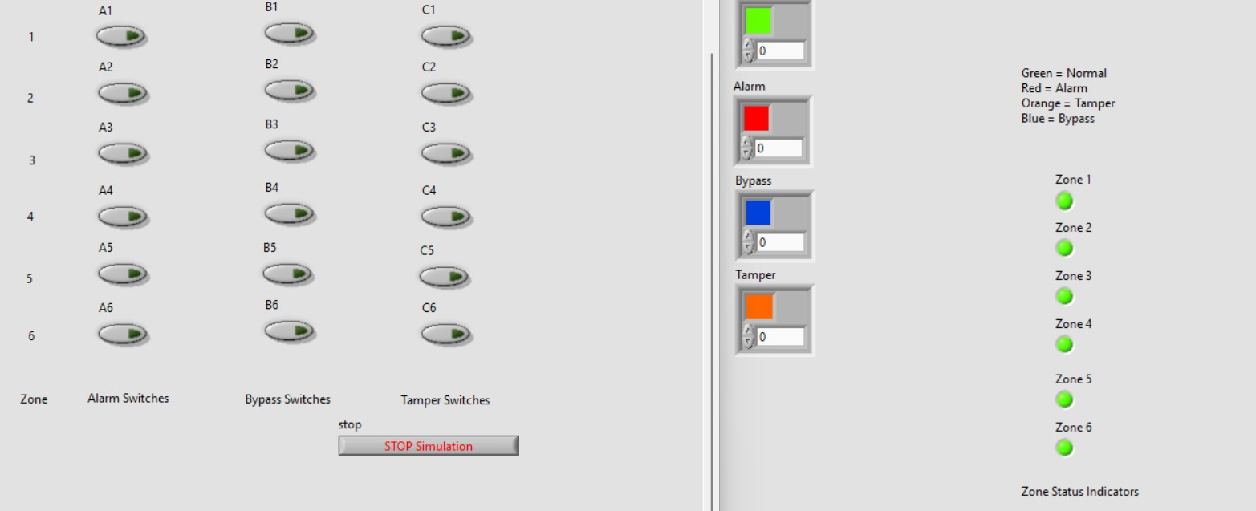Diagram 4: The interface before sending any signal/data

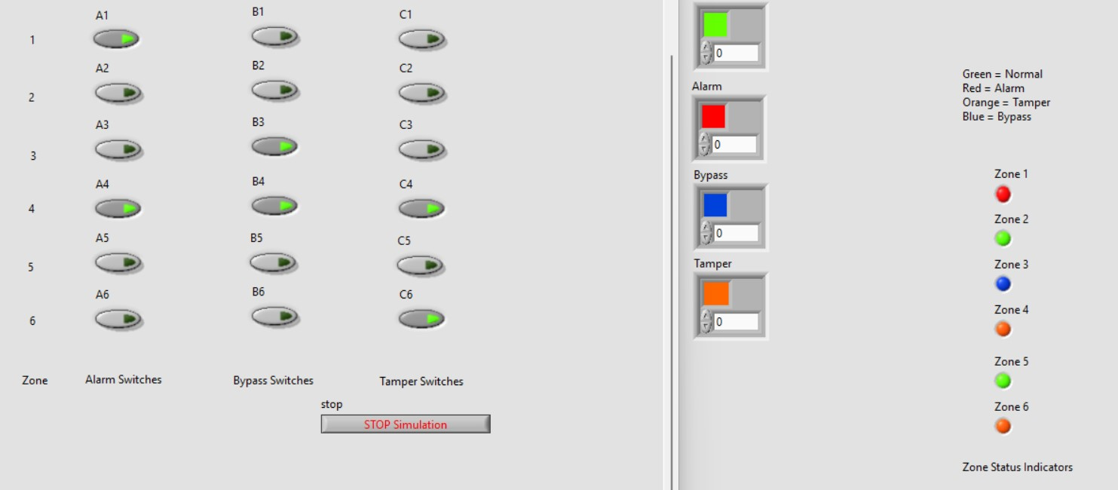

Diagram 5: The interface after sending some signals/data

As shown in diagram 4, the indicators are all green in the server side, which indicates that the zone is “normal”.

As shown in diagram 5, zone 1, 3, 4 and 6 have some changes. The first switch of zone 1 is flicked, and the indicator at the server-side has changed to red, which mean that the zone is in “alarm”. As for the third zone, the second switch is flicked, and the indicator at the server-side has changed to blue, which means that zone 3 is in “bypass” state. As for the fourth zone, all 3 switches are flicked. As the requirements had mentioned, so zone 4 shows orange, which means “tamper”. Lastly, the last zone’s third switch is flickered, and the indicator has turned orange, which means “tamper”.

This is one of the features of the system, where is sends and receives signals, and how it shows it.

## 3.2 Logging Activity

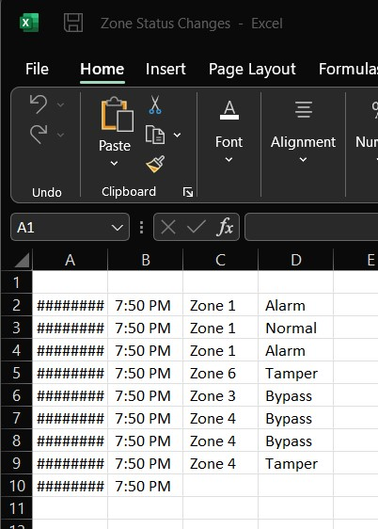

Diagram 6: The file recording down the activities

As shown in diagram 6, the activities of the zones will be recorded and be saved in a Comma-Separated Values, which is a CSV file.

# 4.0 Implementation

## 4.1 Client

## 4.1.1 Interface of Client Side

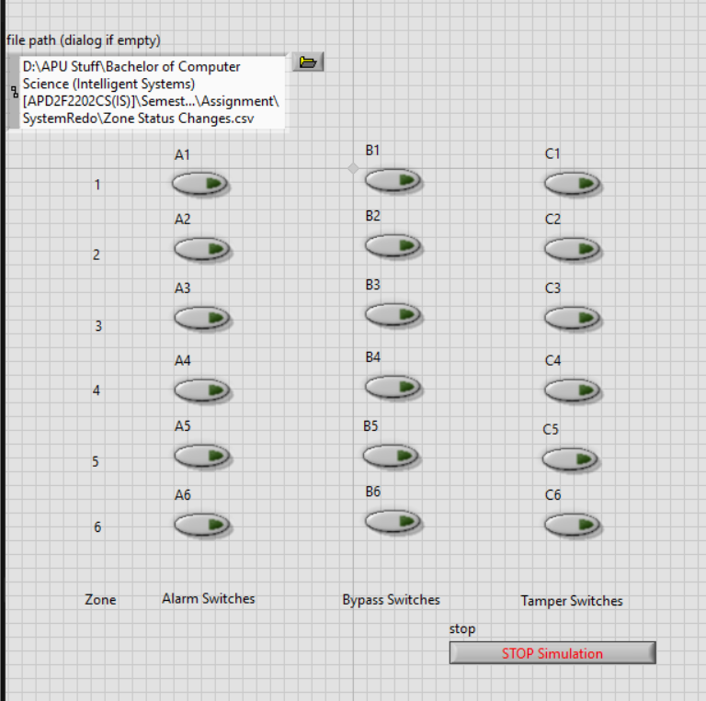

Diagram 6: The Interface Design of Client Side

## 4.1.2 Flow of Data

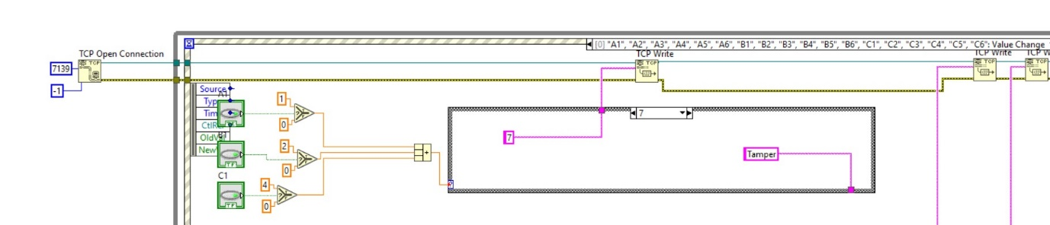

Diagram 7: Flow of Data Being Processed and Sent – Front Part

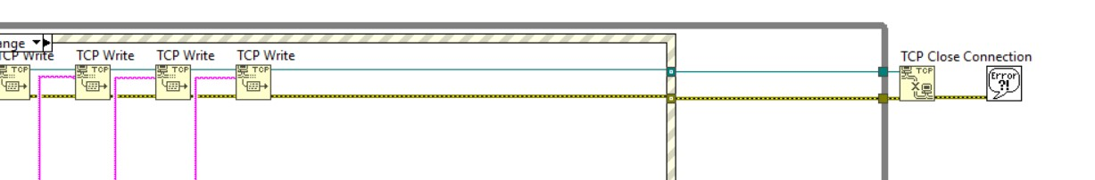

Diagram 8: Flow of Data Being Processed and Sent – End Part

First, the Boolean switches are each connected to different values, 1, 2, 4, and 0. This is used to differentiate what status the zone is in. The 3 values, each coming from a Boolean switch, will be added up. There will be seven values in total.

Then, it is placed in a case structure.

According to diagram 8, after the value of the switches are recorded, and depending on the cases, different values are sent through the TCP connection to the server side.

## 4.1.3 The 7 Cases

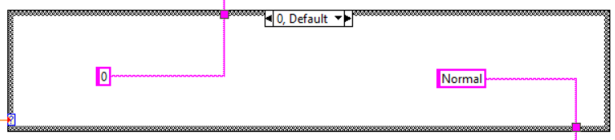

Diagram 9: Case “0”

In case “0”, which means that all three Boolean switches have given the value “0”. It means that all three switches are not activated. Thus, the zone is indicated as “Normal”.

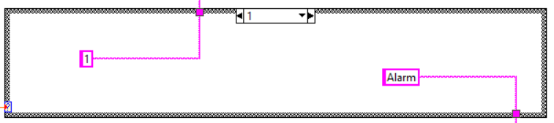

Diagram 10: Case “1”

In case “1”, which means that only the alarm switch is activated. Only value “1” is sent. Thus, the zone is indicated as “Alarm”.

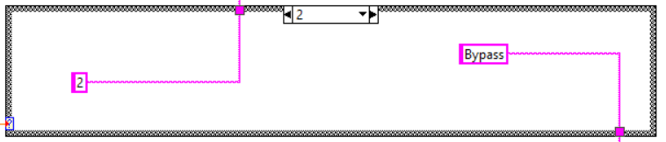

Diagram 11: Case “2”

In case “2”, which means that only the bypass switch is activated. Only value “2” is sent. Thus, the zone is indicated as “Bypass”.

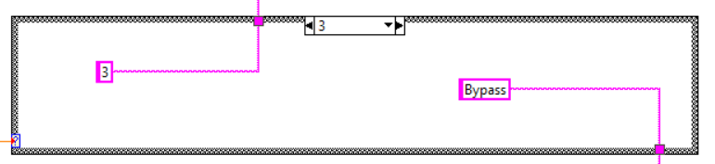

Diagram 12: Case “3”

In case “3”, which means that both the alarm and bypass switch are activated. Value “3” is sent as a combination from the value “1” and “2”. Thus, the zone is indicated as “Bypass”.

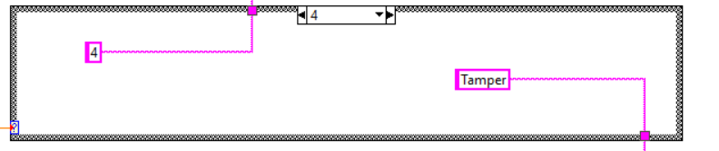

Diagram 13: Case “4”

In case “4”, which means that only the tamper switch is activated. Only value “4” is sent. Thus, the zone is indicated as “Tamper”.

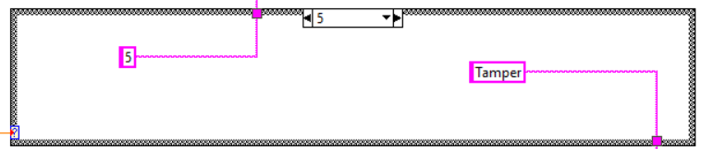

Diagram 14: Case “5”

In case “5”, which means that both the alarm and tamper switch are activated. Value “5” is sent as a combination from the value “1” and “4”. Thus, the zone is indicated as “Tamper”.

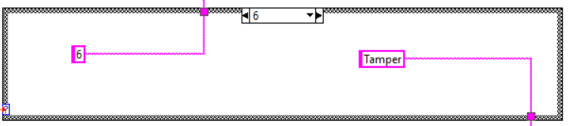

Diagram 15: Case “6”

In case “6”, which means that both the bypass and tamper switch are activated. Value “6” is sent as a combination from the value “2” and “4”. Thus, the zone is indicated as “Tamper”.

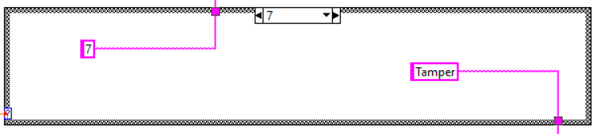

Diagram 16: Case “7”

In case “7”, which means that all three switches are activated. Value “7” is sent as a combination from the value “1”, “2” and “4”. Thus, the zone is indicated as “Tamper”.

## 4.2 Server

## 4.2.1 Interface of Server Side

Diagram 18: The Interface Design of Server Side

## 4.2.2 Flow of Data

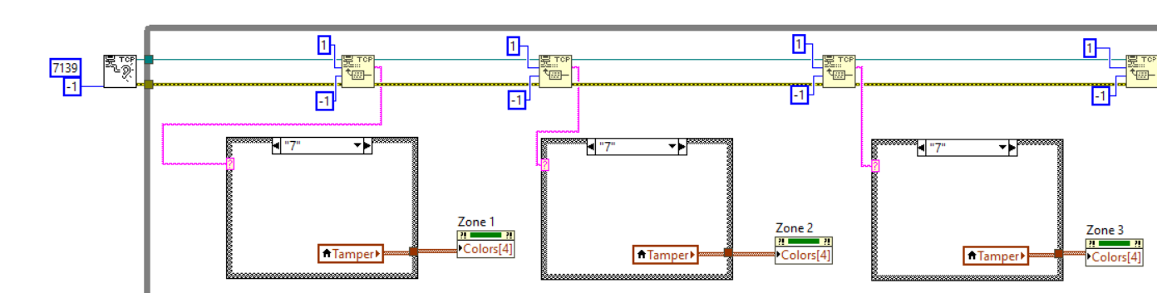

Diagram 19: Flow of Data Being Received and Processed – Front Part

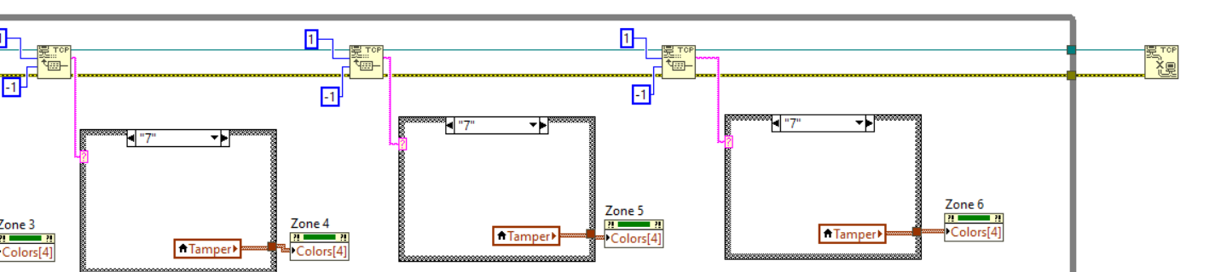

Diagram 20: Flow of Data Being Received and Processed – End Part

First, the value from the client side is received. It is then placed into different case structures based on the zones.

Based on the values sent over, the different cases will also set different colours for the indicator.

Lastly, the TCP connection will be closed.

## 4.2.3 The 7 Cases

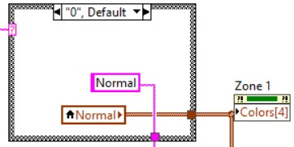

Diagram 21: Case “0”

In case “0”, which means that all three Boolean switches have given the value “0”. It means that all three switches are not activated. Thus, the zone is indicated as “Normal”. The colour of the indicator will be set as “green”.

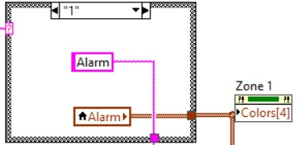

Diagram 22: Case “1”

In case “1”, which means that only the alarm switch is activated. Only value “1” is sent. Thus, the zone is indicated as “Alarm”. The colour of the indicator will be set as “red”.

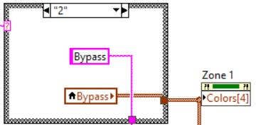

Diagram 23: Case “2”

In case “2”, which means that only the bypass switch is activated. Only value “2” is sent. Thus, the zone is indicated as “Bypass”. The colour of the indicator will be set as “blue”.

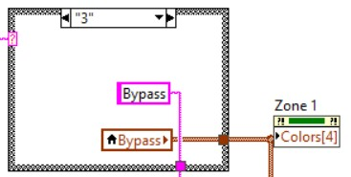

Diagram 24: Case “3”

In case “3”, which means that both the alarm and bypass switch are activated. Value “3” is sent as a combination from the value “1” and “2”. Thus, the zone is indicated as “Bypass”. The colour of the indicator will be set as “blue”.

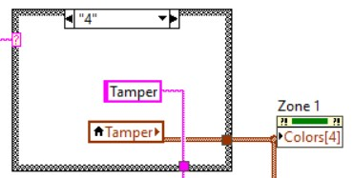

Diagram 25: Case “4”

In case “4”, which means that only the tamper switch is activated. Only value “4” is sent. Thus, the zone is indicated as “Tamper”. The colour of the indicator will be set as “orange”.

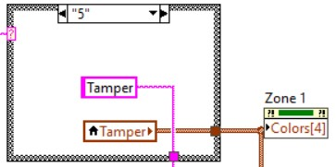d

Diagram 26: Case “5”

In case “5”, which means that both the alarm and tamper switch are activated. Value “5” is sent as a combination from the value “1” and “4”. Thus, the zone is indicated as “Tamper”. The colour of the indicator will be set as “orange”.

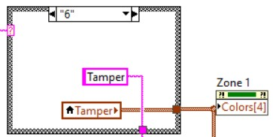

Diagram 27: Case “6”

In case “6”, which means that both the bypass and tamper switch are activated. Value “6” is sent as a combination from the value “2” and “4”. Thus, the zone is indicated as “Tamper”. The colour of the indicator will be set as “orange”.

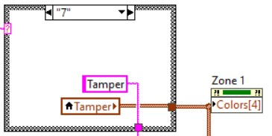

Diagram 28: Case “7”

In case “7”, which means that all three switches are activated. Value “7” is sent as a combination from the value “1”, “2” and “4”. Thus, the zone is indicated as “Tamper”. The colour of the indicator will be set as “orange”.

## 4.2.4 The Setting of Colour for Indicators

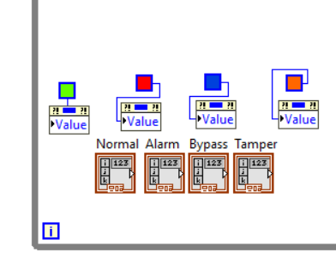

Diagram 29: The Setting of Colour for Indicators

Framed colour boxes are used to set the colours for the four different modes, “normal”, “alarm”, “bypass” and “tamper”. They are set as green, red, blue and orange respectively.

## 4.2.5 The Logging of Data/Signal

Diagram 17: The Logging of Data/Signal

Depending on the cases and zones, different values will be sent to an array. The array gets value from the date and time of the change in values of the switches, and the values of the case and zone. It will then be stored into a file.

## 4.3 Block Diagram

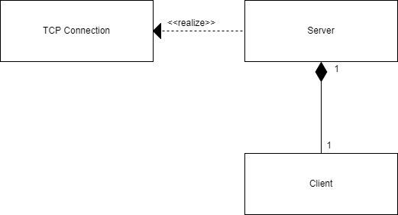

Diagram 30: The Block Diagram

A block diagram shows the overall functional structure of the system. The security system is explained overly here.

First, a connection between the server-side application and client-side application will be built. Then, the client can send data and control the indicators in the server-side application.

# 5.0 Conclusion

In conclusion, the security system was completely implemented with LabVIEW and works efficiently. The system is also designed for extra zone additions.

However, there are also limitations to the system. The start of the system takes awhile to start, so future enhancements may have to focus on improving that. The file log may also be implemented as an online solution with tools like MySQL and others. This can ensure that a copy will always be saved and will not be easily removed should there be an attack. Moreover, extra security enhancements such as user access control or a login page should also be added as anyone can switch the status of zones without any control methods.

As a conclusion, this was a valuable experience and I have learnt a lot from this system. I hope to learn more and further improve this system, and other projects to come.